**Test Plan and Sample interactions -**

1. When the program is started, The first record automatically loaded from database is displayed. The Update button is disabled until new text is entered in any of the text fields.

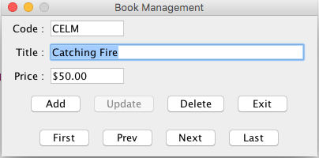

1. When user clicks on the Next button the Next record in the database will be displayed.

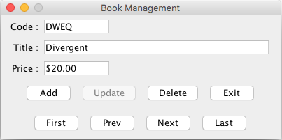

1. When user clicks on the Last button the last record in the database will be displayed.

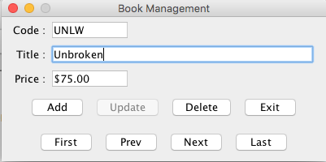

1. When user clicks on the Prev button the previous record in the database will be displayed.

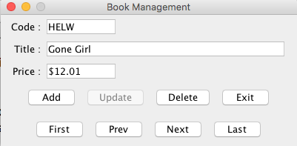

1. When user clicks on the First button the First record in the database will be displayed.

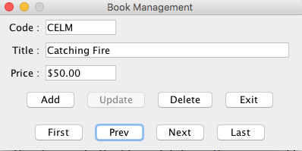

Whenever a new record is displayed, the Update button is disabled.

3. To modify the data for a book, when user makes a change to the title or price fields. At that

point, the Update button is enabled and the Add, Delete, and navigation buttons are

disabled. Then, to save the changes to the file or database, the user need to clicks on the

Update button.

4. To add a record to the file or database, when the user clicks on the Add button. This clears

the text fields, enables the Update button, and disables the Add, Delete, and

navigation buttons. Then, the user can enter the code, title, and price (with or without

dollar sign) for a new book and click on the Update button to save the new record to

the file or database. This record will be added at the end of the file or database.

5. To delete a record, when the user navigates to that record and clicks on the Delete button.

After it deletes the record from the file or database, the program displays the data for

the next record (or the new last record if the deleted record was the last record).

6. To cancel any add or update operation, the user can press Esc key when the focus is

in one of the text fields.

7. To exit from the program at any time, the user can click on the Exit button. This will

cancel any change, addition, or deletion that’s in progress.

8. When user gives wrong input for price the error message will be shown.

